**Chapter 2: Cooling simulation for AM production and product performance**

**Theory**

Additive Manufacturing (AM) is an innovative production technique which provide new, innovative and precise approaches to manufacturing in the industrial sectors. AM is a method of producing components where it is built layer by layer. The production is done through printing the component through e.g. Selective Laser Sintering (SLS) which is based on a digital 3D model of the component to produce.

SLS utilizes lasers to fuse layers of material, which shapes intricate details into a complete component. It is a highly beneficial transformative technology which is flexible while also being able to effectively build complex components. AM and SLS in particular is also very cost efficient as it eliminates waste of material compared to material consumption of more traditional techniques, and it is also quite time efficient.

While SLS comes with many benefits, there is a critical factor which often leaves a remarkable impact on the quality of the components it produces. This factor is cooling. Cooling channels are embedded within the 3D-printed structure, and they play a significant role in the SLS process, as it is one of the main influencers of the thermal dynamics of the production. The solidification process of molten material is highly influenced by the uniformity and rate of cooling, which is impacting the dimensional accuracy, durability, and overall structural properties of the manufactured component.

In order to unveil the impact and importance of proper cooling in SLS, simulations are prone to be a valuable and insightful means of exploring. By performing simulations, one can test how various adjustments of the properties of the cooling channels impacts the final product, and one can analyze these parameters and its impact through statistical analysis.

**Description – Case 1**

This chapter will consider the exploration of cooling simulations for AM production. It consists of two different cases/exercise, where the first one concerns how pressure and volumetric flow rate affects the temperature development of fresh additive manufacturing process. The goal of this particular exercise is to compare how different levels of roughness affects the cooling efficiency.

The simulation was performed using the software “COMSOL Multiphysics”. The results was analyzed with DoE tables using the software “JMP Pro 16”. The statistical analysis uses the level of roughness as a factor, and temperatures measured by 5 different sensors as responses. The simulation was performed with the following levels of roughness:

* 30 µm
* 40 µm
* 50 µm
* 100 µm
* 150 µm

Roughness is a measure which refers to the roughness of the surface on a printed component. Having small levels for roughness means that there are few irregularities in the surface. It is an important factor which can impact several properties on the final product.

**Results – Case 1**

The results of the simulations was studied through plots and DoE analysis. The most relevant results has been included in this report. The results of the simulations were inserted into a spread-sheet in JMP, which again was used to make a full-factorial DoE.

As seen in Figure 1 below, the distribution of sensor temperatures varies for each sensor. This plot is independent of the roughness factor. One may notice that the distribution for each sensor is quite similar. The distance between the median and upper quartile are similar for all sensors, and the length of the whiskers on the boxes are seemingly identical. The interquartile range (IQR) seems to be similar as well. However, while the boxes are quite similar in terms of shape, there are variations in the actual values for each sensor. One may note that the box for Sensor 3 is places a lot higher than e.g. the box for Sensor 1. The median for Sensor 5 appears to be quite close to the lower quartile of Sensor 4. The box-plot indicates that the data distributions are quite similar, though the actual values are different for each sensor.



(Figure 1 – Sensor temperature box-plot)

The DoE was also used as the basis for a regression model using Least Squares. The model provided the effect summary shown below in Figure 2. One may notice that the P-value is very small, which indicates that the effect of the roughness factor is quite large. It also suggests that the observed results are unlikely to have occurred by random chance, which makes it possible to reject the null hypothesis. The relevance of this information can still be discussed, as it could be biased as roughness is the only factor taken into consideration in this analysis.

(Figure 2 – Roughness effect summary)

The final, and arguably the most relevant plot for this analysis is the multiline regression plot as shown below in Figure 3. The diagram describes the expected temperature at each sensor as a function of the roughness. One may note that each line appears to be declining in parallel, but the initial height for each line is quite different. Sensor 3 appears to experience the higher temperatures, while Sensor 1 has the lowest. The regression shows that all sensors measure lower temperatures when the roughness factor increases.



(Figure 3 – Sensor multiline plot)

**Discussion – Case 1**

The plots generated by the DoE analysis gives clear indications of the effect of roughness to the temperature measured at the different sensors. As seen the multiplot regression, it appears that the roughness level is quite influential in terms of temperature development, and that higher levels of roughness will result in lower temperatures and vice versa. The effect of roughness is also indicated through the effect summary, which shows us a very low P-value.

One may note that both the multiline regression and the box-plot indicates quite similar distribution of the value of measurements for each sensor, but that the actual values are not equal to each other. It appears that each sensor experiences the same effect of the roughness parameter. One may imagine that the difference in temperature for each sensor in this scenario is affected by their placement, where sensors near one or several cooling channels may experience lower temperatures compared to sensors which is more distanced from the channels.

Roughness appears to be impactful in terms of temperature, this observation is interesting since one may believe that surface roughness is quite unrelated to temperatures, but this is not the case.

**Description – Case 2**

The second exercise will consider how different properties of the cooling channels affect the temperature over time. This will be conducted through running simulations on a model, where the following properties are altered:

* Channel radius
* Number of channels
* Build height

The results from the simulation will be analyzed using DoE in order to see the effects of these factors while the temperature at a given time is the response variable. In order to perform the simulations we first need to perform lumped analysis in order to calculate the expected cooling time. This is done under the following assumptions:

* Newtonian cooling at 25 C
* Heat transfer coefficient of 10 W/(m^2 * K)
* The target temperature is 60
* Initial temperature is as it is in the MPH-file: 434 K
* Area is 0.17193 m^2 (derived from the MPH-file)
* Volume is 0.0039687 m^3 (derived from the MPH-file)
* The material is Nylon 12
* Initial condition T(0) = Ti

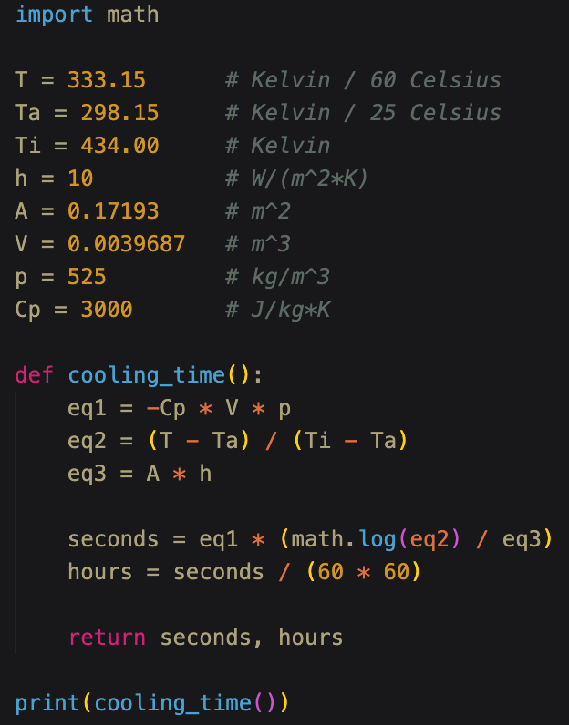Given these values, the following differential equation can be solved in terms of time t:

$$\frac{T\left(t\right)-T_{∞}}{T_{i}-T_{∞}}=e^{-\frac{hA}{Vρc_{p}}∙t}$$

As we have all variables required to solve the equation, we can solve it through a simple python script as seen here (right).

The scripts solves the equation and outputs the following:

$$t≈1.36962 hours$$

This value will therefore be used in the simulation for the parameter “soltime”.

Now as the expected cooling time is calculated, we can perform the simulations and adjust the three channel properties as specified.

The completed simulations will return results in the form of temperature at the center of the powder cake as a function of time. These results will be used for DoE analysis of the three parameters independently and in combination with each other.

**Results – Case 2**

All simulation results were harvested and saved in a spreadsheet. Through DoE analysis, we performed investigations for each parameter independently, and a combined analysis with the result of all simulations in a single DoE.

**Radius Property Investigation**

The radius property seems to be less significant than expected. As shown in Figure 4 below, the lines representing the temperature development at different cooling channel radius seems to be quite synchronous. This indicates that the effect of the radius factor is quite small. If it constituted a greater influence, one would expect to see greater differences in the temperature response having 2mm and 6mm radius.



(Figure 4 – Radius multiline plot)

Due to the similarity of each line in the above figure, we figured it could be a good idea to further investigate this by creating a box-plot. As shown in Figure 5, the data distribution for each simulation are almost identical except for the simulation with a channel radius of 3mm. This further strengthens the claim that the channel radius is of less influence when considering the cooling temperature.



(Figure 5 – Radius box-plot)

As a final measure exploring the significance of the radius property, we used the data to fit a Least Squares regression model in order to inspect the effect summary. Figure 6 below shows a P-value which is very large, while the logarithmic worth is low. This further indicates that the radius property is not impactful for this scenario.

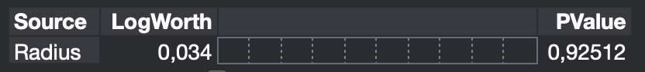

(Figure 6 – Radius effect summary)

**Number of Channels Property Investigation**

Interestingly, the number of channels does not seem to affect the temperature development much either. As shown in Figure 7, the lines representing simulation results for different number of cooling channels seems to almost lie on top of each other.



(Figure 7 – Number of channels multiline plot)

When plotting a box-plot for the factor, we can see in Figure 8 that the upper parts of each box seems to be quite similar. The lower sections of the boxes are different, but this may be because the simulations resulted in measurements of different time spans. The simulation with 4 channels returned measurements for the first 10 hours while the simulation with 9 channels returned measurements only for the first 8 hours. One may also note that the simulation with 9 channels also has a couple of measurements labeled as outliers. These are marked as dots below the lower whisker.



(Figure 8 – Number of channels box-plot)

We fitted a Least Squares regression model for the factor. The effect summary displayed in Figure 9 reveals that the P-value is smaller for this factor compared to the radius factor. It is in fact less than half the size of the P-value for the radius model. Such value still does indicate that the result are likely to occur by random chance. The logarithmic worth appears to be almost 10 times larger for this factor.



(Figure 9 – Number of channels effect summary)

**Height Property Investigation**

When inspecting the height property, we achieved some different results. As shown in Figure 10, there is a clear difference in the temperature development when the height property is at 100mm compared to 150mm. It appears that the distance between the lines decreases over time, which indicates that the temperature is stagnating somewhere above 300K, which seems logical considering the parameters in the lumped analysis.



(Figure 10 – Height multiline plot)

The effects summary for this property, shown in Figure 10, shows that the P-value is very large and indicates a strong evidence for the null hypothesis. Logarithmic worth appears to be small as well. This was quite unexpected since the height property was the only property where we managed to see clear differences in the multiline plot.

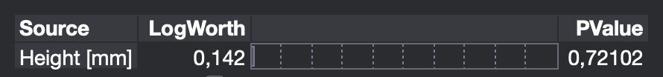

(Figure 11 – Height effect summary)

**Combined Property Investigation**

When performing the combined property investigation, we included the results of all the 10 simulations into a single DoE. It did not appear to be any noteworthy graphs to include since the graphs were quite similar and is already included in the report. However, we considered the effect summary to be of significance in this investigation, as we were curious to see if there were any changes to the effect summary when considering all the factors combined rather than investigating them independently.

For the effect summary, we fitted a Least Squares regression model, where all three channel properties as well as time were set as factors, and the temperature attribute represented the response variable. As seen in Figure 12, there was in fact some difference in factor significance when performing this investigation. We can ignore the time property as it is not one of the factors we are investigating. We can see that the height factor appears to be the most significant property by far. The P-value is very small which makes it possible to reject the null hypothesis. The other factors seems to be less significant still, and we can also note that the two latter factors has switched their ranking in significance compared to the isolated investigation of each factor.

(Figure 12 – Combined effect summary)

The final prediction of time vs. temperature at the center of the powder cake when taking all channel properties into consideration is shown in Figure 13 below. The dots which lies above the prediction line corresponds to the points from the height simulation where the height were set to 150mm.



(Figure 13 – Predicted time vs. temperature)

**Discussion – Case 2**

The results of the investigation were quite surprising. The analysis indicates that the only significant factor which also could reject the null hypothesis is the height property of the cooling channels. The authors finds it highly unlikely that the channel radius and the number of channels has little to no significance when considering the cooling temperature. It seems very logical that both the number and the size of the cooling channels should affect the cooling. This raises the suspicion that we might have done something wrong.

When inspecting the raw data harvested from the simulation results, we can clearly see that the measurements are quite similar for all simulations. This indicates that if there was a mistake, it must have occurred in the simulation itself. The members of the project revised the lumped analysis, and we have concluded that our calculation of the “soltime” parameter is likely to be correct. This leaves the simulation itself to be the only likely section where the potential error occurred. We performed the simulations again several times, carefully following the instructions in the assignment. After, we compared the results for each simulation for each scenario in order to see if there were any noticeable differences in the results we got. All results were similar to our initial attempt. The authors have therefore concluded that the potential error must be somewhere else, or that there is no error in our approaches after all.

We are somewhat uncertain whether our simulations and investigations were correct for this assignment. As far as we can see, there is nothing wrong with the way we conducted the simulations, and the results were similar every time we tried, indicating that our results were not as non-significant as the effects summaries indicated. Although we find it unlikely that the channel properties did not affect the temperature to a greater than what we observed, we are choosing to have faith to our results to some extent. If the simulations are to be considered to be correctly executed, we can conclude that the height factor is the most significant property of the cooling channels when considering the cooling phase of this additive manufacturing process.